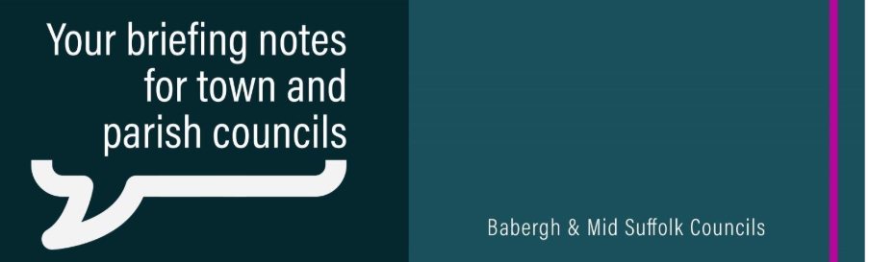
Government confirms ambitious new future for local government in Suffolk
The Secretary of State for Housing, Communities and Local Government has confirmed that three unitary councils will be created in Suffolk replacing the current system made up of Suffolk County Council and the five district and borough councils: Babergh, East Suffolk, Ipswich, Mid Suffolk and West Suffolk.

‘Shape the future of your community’ – Councils step in to provide funding for Neighbourhood Plans
Communities are being encouraged to shape the future of their area by creating a Neighbourhood Plan – after Babergh and Mid Suffolk District Councils stepped in with funding to support them.

Emergency support call for households hit by soaring heating oil costs
Thousands of households facing soaring heating oil costs need urgent government support, community leaders in Babergh and Mid Suffolk have warned.

Clean air milestone reached in Sudbury as Cross Street pollution zone revoked
After years of sustained improvement in local air quality, Babergh District Council has confirmed that an Air Quality Management Area (AQMA) in Cross Street, Sudbury, has been formally revoked, marking a significant milestone in combatting the effects of pollution.

New ‘Grazing Walks’ leaflet launches to promote car-free days out
Babergh District Council has helped to introduce a new Grazing Walks illustrated map and visitor leaflet, designed to help visitors enjoy easy, sustainable days out and short breaks across the Harwich Haven, using train travel and the Harwich Harbour Ferry.

Council moves to deliver café and toilets project as part of wider park improvements
Stalled plans for a new café and toilets in Belle Vue Park, Sudbury, could be delivered as councillors consider additional funding.

Skate park and medieval church among projects to receive £295k boost
A brand-new skate park for Brantham and a project to futureproof Great Cornard’s medieval church to support community needs are each to receive a £100k boost from Babergh District Council.

